Multiple-choice section

|  |  |  |  |  |  |  |
| --- | --- | --- | --- | --- | --- | --- |
| Question | 1 | 2 | 3 | 4 | 5 | 6 |
| Answer | B | D | A | D | C | B |

Question 1 [8.3]

B

P(x) = x3 – x2 – 4

P(-2) = (-2)3 – (-2)2 – 4

= -8 – 4 – 4

= -16

Question 2 [8.2]

D

To transform y = x2 to y = -x2, reflect in the x-axis.

To transform y = -x2 to y = -3x2, dilate by a factor of 3 in the y-direction.

To transform y = -3x2 to y = 6 – 3x2, translate 6 units up.

Question 3 [8.3]

A

P(x) = x2 – 2x4 + 7

= -2x4 + x2 + 7

Degree = 4; Leading coefficient = -2; Constant = 7

Question 4 [8.3]

D

P(x) = x3 – x2 + 3x + 2

P(1) = 13 – 12 + 3 × 1 + 2

= 1 – 1 + 3 + 2

= 5

Question 5 [8.5]

C

y = 2x3 + 5x2 – x + 6

For x = 0: y = 6

Question 6 [8.2]

B

y = x3

Dilating by a factor of 5: y = 5x3

Translating the graph 2 units to the right: y = 5(x – 2)3

Translating the graph 1 unit down: y = 5(x – 2)3 – 1

Multiple-choice total marks: 6

Short answer section

Question 7 3 marks [8.1, 8.3]

(a) The degree of a polynomial is the value of the highest power in the polynomial.

(b) The equation y = 3x2 – 4x + 1 is a non-monic quadratic equation.

(c) In a polynomial, the term with the highest power is called the leading term.

Question 8 2 marks [8.2]

When a polynomial is reflected in a line, the result is a mirror image of the original graph. Each point on the image is as far from the line of reflection as the original point on the polynomial but on the opposite side of it.

Question 9 4 marks [8.2]

(a), (c)

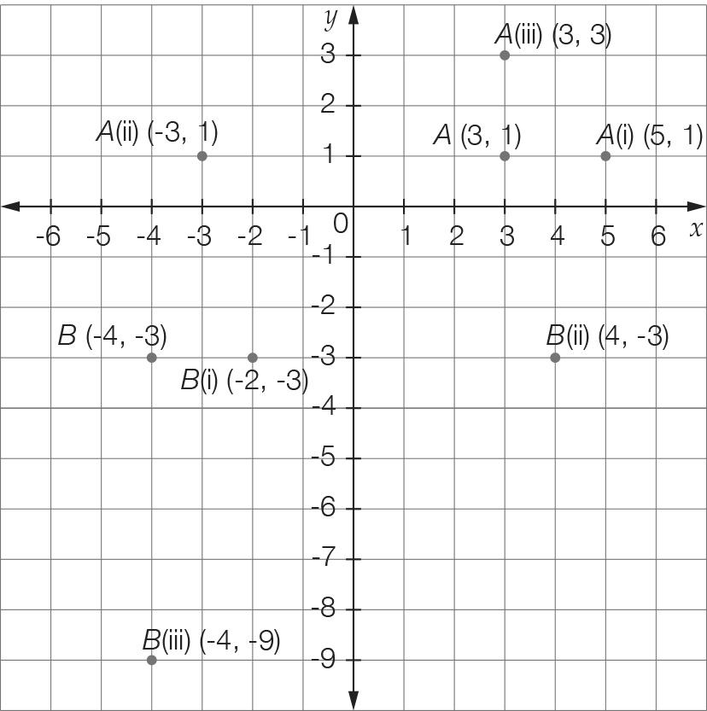

(b) A (i) (5, 1) (ii) (-3, 1) (iii) (3, 3)

B (i) (-2, -3) (ii) (4, -3) (iii) (-4, -9)

Question 10 8 marks [8.2]

(a), (c)

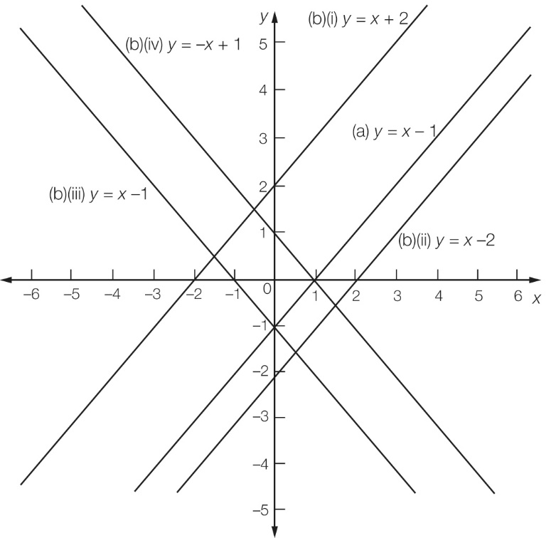

(b) (i) y = x + 2 (ii) y = x – 2 (iii) y = -x – 1 (iv) y = -x + 1

Question 11 4 marks [8.2]

(a) (i) (2, -4) (ii) (0, 0) (iii) (0, 0) and (4, 0)

(b), (c)

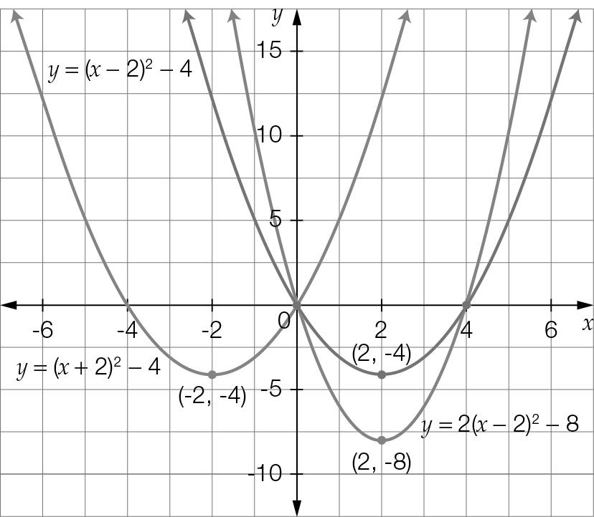

(c) (i) y = (x + 2)2 – 4 (ii) y = 2(x – 2)2 – 8

Question 12 3 marks [8.2]

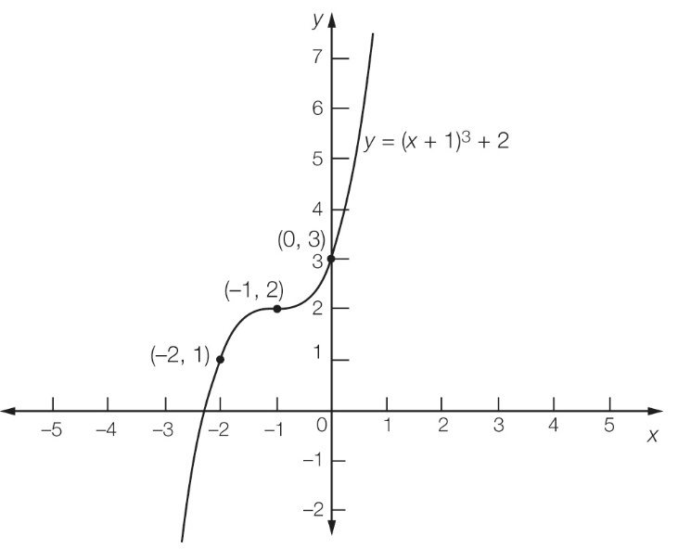

Point of inflection = (-1, 12)  
y-intercept = (0, 3)   
Required point = (-2, 1).

Question 13 4 marks [8.2]

(a) y = x2  
Translate 2 to the left: y = (x + 2)2   
Translate 2 to the left and 1 down: y = (x + 2)2 – 1

(b) y = x2  
Reflect in the x-axis: y = -x2  
Reflect in the x-axis, dilate by 2 in the x-direction: y = -2x2  
Reflect in the x-axis, dilate by 2 in the y-direction, translate 3 to the left: y = -2(x + 3)2

Question 14 4 marks [8.5]

For x = 0, y = c

c = -4

For x = -2, 4a – 2b – 4 = 0 [1]

For x = 1, a + b – 4 = 0 [2]

Add equations 2 × [2] and [1]

6a = 12

a = 2

By substitution in equation [1]

2 + b − 4 = 0

b = 2

a = 2, b = 2, c = -4

Question 15 2 marks [8.4]

P(x) = 5x2 + 7x + 2

P(-1) = 5 – 7 + 2

= 0

Given that P(-1) = 0, then x + 1 is a factor.

Question 16 2 marks [8.3]

Answers will vary, but the polynomial must have four terms, the highest power of x must be 5 and the coefficient of this term must be a negative.

e.g. -2x5 + 3x2 + 5x – 2

Question 17 4 marks [8.3, 8.4]

(a) P(1) = 1 – 1 – 4 + 4

= 0

So x – 1 is a factor.

x2− 0x–4

x – 1 ) x3 – x2 − 4x + 4

-(x3 – x2)

-4x +4

-(-4x + 4)

0

x3 – x2 − 4x + 4 = (x – 1)(x2 – 4)

= (x – 1)(x + 2)(x – 2)

(b) x3 – x2 − 4x + 4

= (x – 1)(x + 2)(x – 2)

= 0

So x = 1, x = -2 or x = 2.

Question 18 4 marks [8.3]

a(x) = 2x – 1, b(x) = 1 – x2 and c(x) = 3x2 + 4x − 2

2a(x) × b(x) + c(x)

= 2(2x – 1)(1 – x2) + (3x2 + 4x – 2)

= 2(-2x3 + 2x + x2 – 1)+ (3x2 + 4x – 2)

= -4x3 + 4x + 2x2 – 2 + 3x2 + 4x – 2

= -4x3 + 5x2 + 8x – 4

Question 19 2 marks [8.3]

Answers will vary, but polynomial must be a cubic and P(4) must be zero.

Question 20 2 marks [8.3]

2x2 – kx + 16

Substitute x = 4:

32 – 4k + 16 = 0

4k = 48  
k = 12

Short answer total marks: 52

Extended answer section

Question 21 5 marks [8.2]

(a) y = 5 – 0.2(x – 8)2 + 4  
= 9 – 0.2(x – 8)2

(b) Let y = 0  
9 – 0.2 (x – 8)2 = 0  
45 – (x – 8)2 = 0  
( + (x – 8))( − (x – 8)) = 0  
x – 8 =   
= 8   
x = 1.3 m and 14.7 m

(c) Maximum height at vertex (8, 9) is 9 m.

Question 22 6 marks [8.5]

(a) y = 0.01(x3 – 23x2 + 90x)  
= 0.01x(x2 – 23x + 90)   
= 0.01x(x – 5)(x – 18)

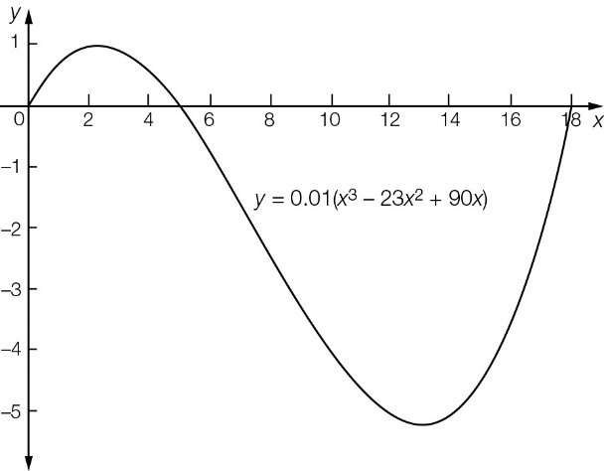

(b) x = 0, 5, 18 (where y = 0)

(c) Distance from one side to the other  
= 18 – 0  
= 18 m

Question 23 5 marks [8.5]

(a) Graph shown where d is on the y-axis and w is on the x-axis.

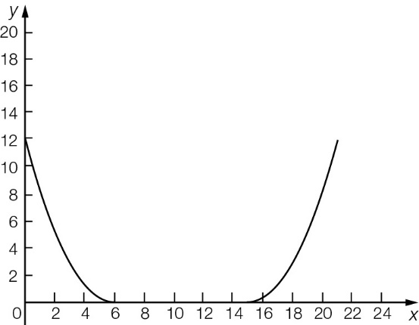

(b) 21 cm

(c) Depth of bowl (where x = 0)  
= (-6)2  
= 12 cm

Extended answer total marks: 16

TOTAL test marks: 74